R Notebook

This is an [R Markdown](http://rmarkdown.rstudio.com) Notebook. When you execute code within the notebook, the results appear beneath the code.

Try executing this chunk by clicking the *Run* button within the chunk or by placing your cursor inside it and pressing *Ctrl+Shift+Enter*.

plot(cars)

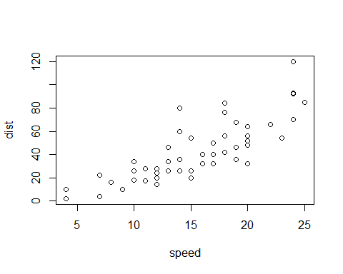

list.files('~')

## [1] "Custom Office Templates" "desktop.ini"   
## [3] "My Music" "My Pictures"   
## [5] "My Videos"

setwd("C:/Users/MY PC/Desktop/R lab1")  
d1 = read.table('RTestData.txt', header = TRUE)  
d1

## id strep prev lepto fuso veil time status pocket deepest  
## 1 S001 57.4 10.2 0.1 0.0 6.9 1 2 2.7 3.8  
## 2 S001 26.0 0.0 25.6 0.0 6.3 2 2 2.7 3.0  
## 3 S006 19.0 24.2 4.8 5.7 4.2 1 1 2.5 3.2  
## 4 S006 15.2 4.2 0.2 2.6 3.4 2 1 2.4 3.2  
## 5 S007 33.2 2.3 7.4 1.3 12.0 1 2 2.4 2.7  
## 6 S007 18.0 0.3 13.6 1.7 13.8 2 2 2.4 2.8  
## 7 S008 12.3 11.5 9.1 5.5 5.7 1 1 2.6 3.5  
## 8 S008 3.3 24.7 6.3 10.4 3.0 2 1 2.5 3.2  
## 9 S009 9.1 32.7 1.9 14.3 1.6 1 1 2.9 4.0  
## 10 S009 22.0 8.9 17.8 4.8 14.0 2 1 2.5 3.5  
## 11 S012 11.0 17.5 8.9 3.4 4.0 1 0 1.6 2.0  
## 12 S012 1.8 11.7 29.1 8.4 3.7 2 0 2.5 2.7  
## 13 S013 4.8 10.6 3.7 10.5 1.0 1 0 2.4 3.3  
## 14 S013 6.6 3.4 13.9 9.0 4.1 2 0 2.6 3.5  
## 15 S015 9.1 19.5 14.3 6.7 16.9 1 1 2.6 3.7  
## 16 S015 9.7 7.3 14.7 6.2 22.8 2 1 2.1 2.8  
## 17 S016 18.1 9.6 5.6 6.7 7.9 1 2 2.7 3.5  
## 18 S016 8.8 8.3 6.0 8.1 4.9 2 2 2.7 3.5  
## 19 S019 14.2 10.4 9.0 11.8 4.9 1 1 2.7 3.8  
## 20 S019 8.1 3.1 11.2 25.0 3.8 2 1 2.6 3.7  
## 21 S020 8.8 10.7 17.4 5.1 1.7 1 1 2.5 3.0  
## 22 S020 24.1 7.7 10.8 5.8 11.8 2 1 2.4 2.7  
## 23 S022 3.6 27.4 9.6 9.3 1.6 1 1 2.5 3.2  
## 24 S022 9.0 9.6 16.3 8.3 2.3 2 1 2.4 2.7  
## 25 S023 9.0 35.0 3.2 7.6 3.4 1 2 3.2 5.2  
## 26 S023 3.1 22.0 13.1 6.7 4.8 2 2 3.2 4.8  
## 27 S024 5.1 9.2 4.9 10.5 1.3 1 1 3.0 4.2  
## 28 S024 23.3 7.6 18.7 9.1 5.2 2 1 2.7 3.7  
## 29 S025 12.2 0.3 2.8 1.4 0.6 1 0 2.5 2.8  
## 30 S025 3.3 0.5 2.0 5.7 0.1 2 0 2.9 3.0  
## 31 S032 11.4 15.7 18.6 6.6 3.6 1 0 1.6 2.2  
## 32 S032 5.3 14.1 15.0 17.1 4.7 2 0 2.0 2.8  
## 33 S033 10.7 18.8 10.2 7.5 9.0 1 0 1.3 2.0  
## 34 S033 8.5 17.0 17.7 8.7 3.5 2 0 2.7 4.0  
## 35 S035 10.1 39.9 4.4 7.1 4.1 1 1 3.0 3.8  
## 36 S035 6.2 26.2 13.3 6.4 2.1 2 1 2.5 3.3  
## 37 S038 9.2 12.4 3.5 11.5 11.5 1 0 2.5 3.8  
## 38 S038 5.0 11.5 5.8 17.8 5.3 2 0 3.0 4.2  
## 39 S039 3.9 14.2 13.8 18.5 1.9 1 0 3.1 4.0  
## 40 S039 11.4 11.7 9.3 7.5 11.7 2 0 3.2 4.5  
## 41 S040 18.6 2.4 10.3 8.8 6.4 1 1 2.7 3.7  
## 42 S040 5.0 16.9 4.4 15.4 4.7 2 1 2.6 3.3  
## 43 S043 61.7 1.7 0.4 2.6 2.4 1 2 2.5 3.3  
## 44 S043 4.3 19.4 3.5 9.1 1.9 2 2 2.5 3.2  
## 45 S045 16.1 6.9 9.9 10.1 3.1 1 2 2.9 4.2  
## 46 S045 2.9 6.6 4.3 17.1 0.8 2 2 2.9 4.2  
## 47 S049 0.9 6.6 3.2 7.1 6.7 1 1 3.8 4.3  
## 48 S049 2.7 20.2 8.3 12.5 5.6 2 1 3.4 3.8  
## 49 S051 6.6 10.9 11.7 9.7 5.4 1 0 2.3 3.0  
## 50 S051 16.2 8.0 12.2 11.6 4.1 2 0 2.4 3.2  
## 51 S052 2.9 3.1 26.6 9.3 9.8 1 0 1.6 1.8  
## 52 S052 6.4 19.6 5.9 11.8 14.2 2 0 2.3 2.7  
## 53 S055 10.7 7.6 15.1 12.3 3.8 1 0 2.7 3.7  
## 54 S055 5.6 12.2 10.1 15.0 1.8 2 0 3.0 4.7  
## 55 S056 6.1 13.9 3.6 23.8 0.8 1 0 2.8 4.2  
## 56 S056 8.1 10.6 7.2 19.5 7.8 2 0 3.1 4.2  
## 57 S057 19.1 10.4 9.6 7.0 9.3 1 0 1.9 2.3  
## 58 S057 26.2 7.4 17.3 10.5 1.9 2 0 3.4 3.8  
## 59 S058 22.1 11.0 11.9 11.8 4.4 1 0 2.6 2.3  
## 60 S058 7.9 5.3 21.0 13.4 26.2 2 0 2.8 3.3  
## 61 S060 4.0 29.9 18.9 3.2 4.1 1 0 2.5 3.0  
## 62 S060 40.4 8.0 1.9 4.1 8.9 2 0 2.8 3.2  
## 63 S061 36.5 1.9 10.8 4.9 10.8 1 1 2.7 2.5  
## 64 S061 23.0 1.5 18.1 11.2 7.4 2 1 2.5 2.7  
## 65 S062 39.8 0.7 7.6 0.3 4.5 1 0 2.3 3.0  
## 66 S062 24.0 7.1 21.1 1.9 8.8 2 0 2.4 3.0  
## 67 S063 19.9 0.0 2.5 0.0 0.1 1 0 2.5 2.8  
## 68 S063 24.8 2.5 9.1 7.0 3.2 2 0 2.7 3.7  
## 69 S065 7.1 12.3 2.5 11.0 5.1 1 0 2.4 3.7  
## 70 S065 11.8 10.2 9.0 15.7 6.3 2 0 2.7 3.3  
## 71 S068 15.9 23.0 9.8 6.7 7.3 1 0 2.2 3.7  
## 72 S068 16.8 11.6 27.1 7.9 2.2 2 0 2.8 4.2

#fuso  
d1$fuso

## [1] 0.0 0.0 5.7 2.6 1.3 1.7 5.5 10.4 14.3 4.8 3.4 8.4 10.5 9.0 6.7  
## [16] 6.2 6.7 8.1 11.8 25.0 5.1 5.8 9.3 8.3 7.6 6.7 10.5 9.1 1.4 5.7  
## [31] 6.6 17.1 7.5 8.7 7.1 6.4 11.5 17.8 18.5 7.5 8.8 15.4 2.6 9.1 10.1  
## [46] 17.1 7.1 12.5 9.7 11.6 9.3 11.8 12.3 15.0 23.8 19.5 7.0 10.5 11.8 13.4  
## [61] 3.2 4.1 4.9 11.2 0.3 1.9 0.0 7.0 11.0 15.7 6.7 7.9

#attached(d1)  
#fuso  
d1$strep = as.numeric(as.character(d1$strep))  
#hist(d1$srep)  
#hist(1strep)  
t.test(d1$strep, d1$fuso)

##   
## Welch Two Sample t-test  
##   
## data: d1$strep and d1$fuso  
## t = 3.3584, df = 97.994, p-value = 0.001117  
## alternative hypothesis: true difference in means is not equal to 0  
## 95 percent confidence interval:  
## 2.116011 8.228433  
## sample estimates:  
## mean of x mean of y   
## 13.958333 8.786111

#t.test(1strep, d1$fuso)  
#d2 = read.csv('primer.csv')  
qqnorm(d1$strep)  
qqline(d1$strep)

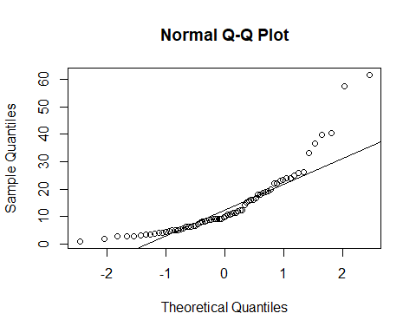

lstrep = log(d1$strep)  
d1 = d1[!is.na(d1$strep), ]

Add a new chunk by clicking the *Insert Chunk* button on the toolbar or by pressing *Ctrl+Alt+I*.

When you save the notebook, an HTML file containing the code and output will be saved alongside it (click the *Preview* button or press *Ctrl+Shift+K* to preview the HTML file).

The preview shows you a rendered HTML copy of the contents of the editor. Consequently, unlike *Knit*, *Preview* does not run any R code chunks. Instead, the output of the chunk when it was last run in the editor is displayed.

head(airquality)

## Ozone Solar.R Wind Temp Month Day  
## 1 41 190 7.4 67 5 1  
## 2 36 118 8.0 72 5 2  
## 3 12 149 12.6 74 5 3  
## 4 18 313 11.5 62 5 4  
## 5 NA NA 14.3 56 5 5  
## 6 28 NA 14.9 66 5 6

attach(airquality)  
qqnorm(Ozone)  
qqline(Ozone)

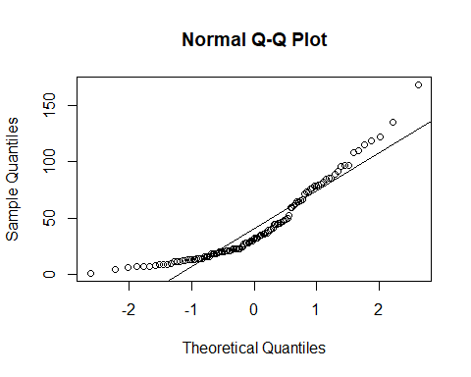

hist(Ozone, main = "Histogram of Ozone", xlab = "Ozone")

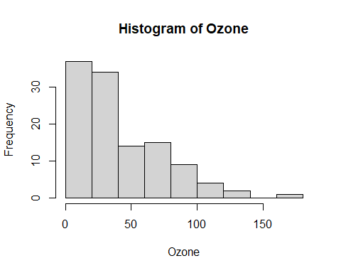

shapiro.test(Ozone)

##   
## Shapiro-Wilk normality test  
##   
## data: Ozone  
## W = 0.87867, p-value = 2.79e-08

Ozone_log <- log(Ozone +1)